Rat Cage Lid Modification Procedure

Parts List:

|  |  |  |  |
| --- | --- | --- | --- |
| Name | Part Number | Vendor / Part Type | Qty / Unit |
| Rat Cage Lid |  | Purchased-Techniplast | 1 |
| RC Panel Front | J009859 | Custom machined | 1 |
| RC Panel Side | J009838 | Custom machined | 1 |
| RCBH4 Weldment | J008644 | Custom weldment-GoProto | 1 |
| RC Bracket Front | J009600 | Custom sheetmetal-GoProto | 1 |
| RC Bracket Long | J009835 | Custom sheetmetal-GoProto | 1 |
| RC Bracket Side | J009836 | Custom sheetmetal-GoProto | 1 |
| Card Holder Bracket | J010308 | Custom sheetmetal-GoProto | 1 |
| bottom taper section of right water bottle holder |  | Purchased-Part of Techniplast Lid | 1 |
| Rat Water Bottle Transition |  | Custom machined | 1 |
| Rivets - .063” - .125” | 97447A015 | McMaster | 10 |
| Rivets - .126” - .187” | 97447A020 | McMaster | 10 |
| Rivets - .188” - .25” | 97447A025 | McMaster | 2 |
| 18-8 SS No. 4 Washer | 98019A309 | McMaster | 8 |
| 18-8 SS No. 5 Washer | 90945A712 | McMaster | 10 |
| Epoxy, 3M DP125 | 7467A65 | McMaster | 1 |

Tools List:

|  |  |  |  |
| --- | --- | --- | --- |
| Name | Part Number | Vendor | Quantity/Unit |
| Angle Grinder/Dremel |  |  |  |
| 1/8” Drill Bit |  |  |  |
| #28 Drill Bit |  |  |  |
| Power Drill |  |  |  |
| Pliers |  |  |  |
| Epoxy Applicator Gun | 74695A71 | McMaster | 1 |
| Masking Tape |  |  | 1 |
| Binder Clips (optional) |  |  | 2 |

Procedure

1. Cut Cage Lid
   1. Cut water bottle holder sections off the lid – cut lines shown in red on right picture
   2. The left and right sides will be cut at different locations

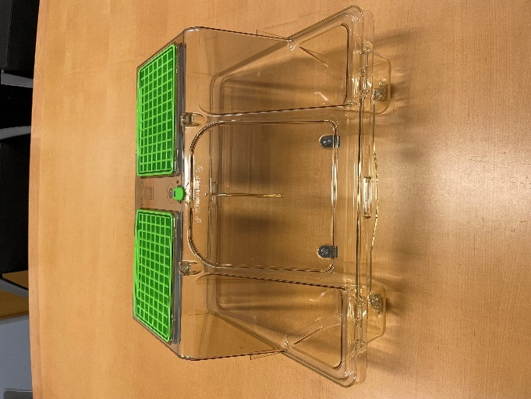 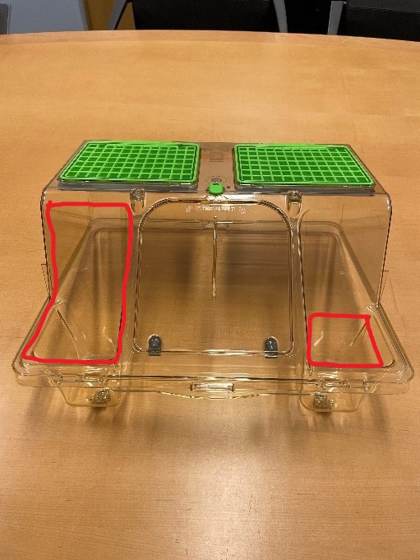

* 1. Cut right bottle holder section at thick red line in photo below – there will be a natural seam to follow
  2. Save the bottom taper section of the holder and metal flap assembly and for reattachment to modified cage

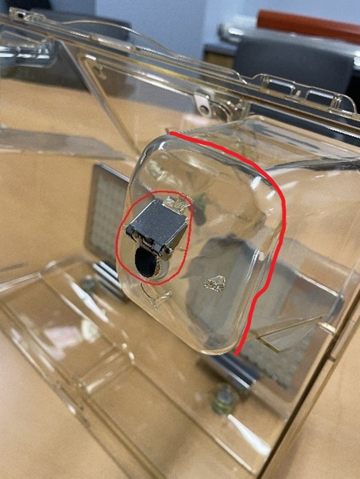

* 1. Grind off the front card holder on the left side of the cage

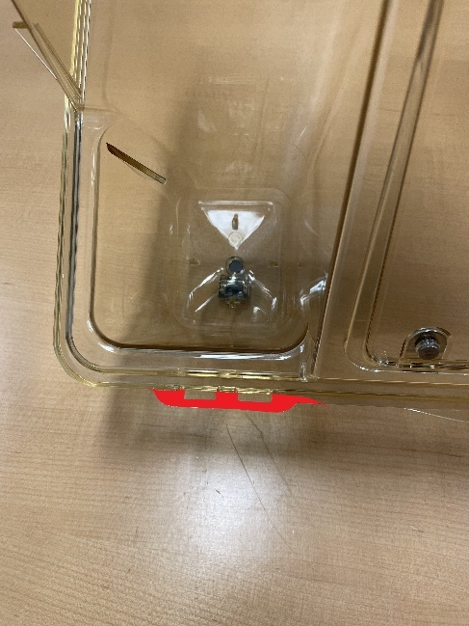

1. Assemble Flat Cover

Parts:

|  |  |
| --- | --- |
| Part Number | Quantity |
| J009859 | 1 |
| J009838 | 1 |
| J009600 | 1 |
| J009835 | 1 |
| J009836 | 1 |
| 97447A015 | 10 |
| 90945A712 | 2 |

* 1. Rivet front panel (J009859) and side panel (J009838) together using the long bracket (J009835) and six 97447A015 rivets
     1. Proper orientation of the panels, with respect to each other:

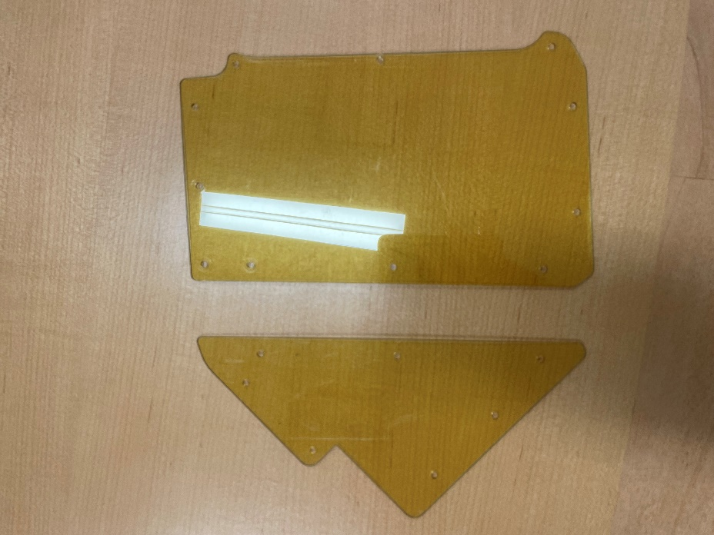

* + 1. The bracket is not symmetrical – the side with square corners should be attached to the front panel
    2. Bracket should be attached on the inside of the panels, with rivets attached from the outside, so the flat head is on the outside of the plastic

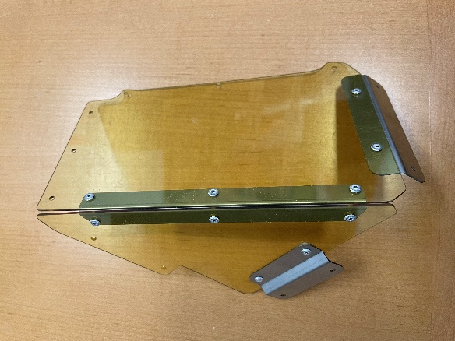 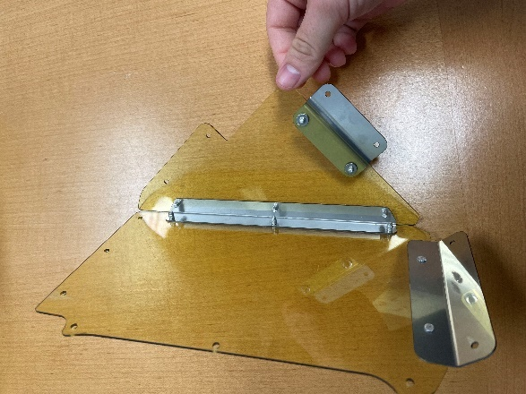

* 1. Rivet front bracket (J009600) to the front panel with two 97447A015 rivets
     1. Bracket should be on the inside of the panel, with the bracket extending down below the panel
     2. Rivets attached from the outside, so the flat head is on the outside of the plastic

* 1. Rivet side bracket (J009836) to the side panel with two 97447A015 rivets
     1. Bracket should be on the outside of the panel, with the short side of the “z” attached to the panel and the bracket jutting out away from the panel
     2. Rivets will be attached through the bracket into the panel – use two washers (90945A712) behind the panel

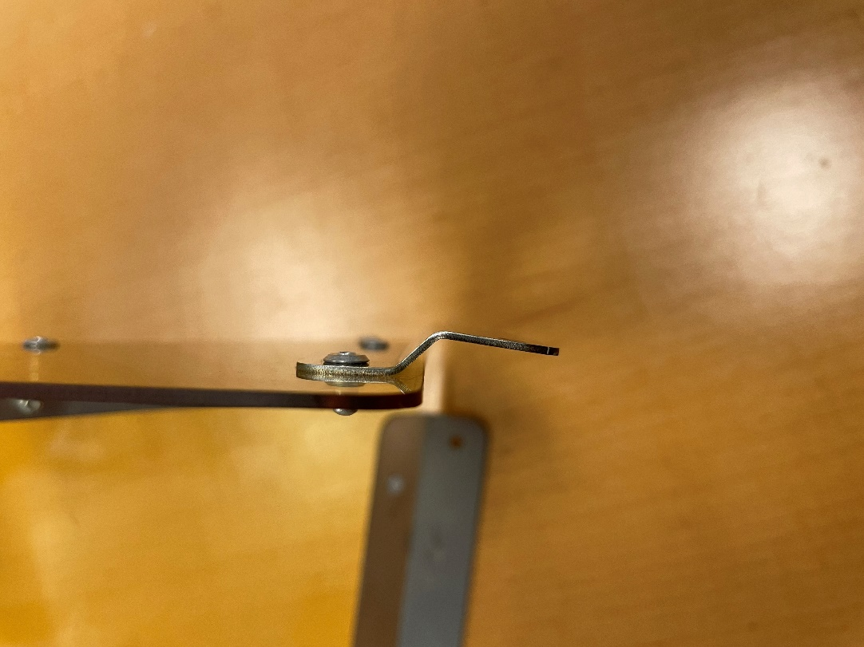

1. Attach Flat Cover Assembly to Cage

Parts:

|  |  |
| --- | --- |
| Part Number | Quantity |
| 97447A020 | 10 |
| 90945A712 | 8 |
| J010308 | 1 |
| 97447A025 | 2 |

* 1. Use cover assembly as guides to drill mounting holes through cage lid – hole locations marked in red
     1. Flat panel assembly mounts on left side of lid when looking at the front
     2. Drill initial holes with 1/8” drill bit

* + 1. Can be helpful to hold the cover assembly in place with binder clips while drilling
  1. Remove cover assembly and enlarge holes with #28 drill bit
  2. Attach cover assembly to lid
     1. The eight rivets going through the front and side walls, as opposed to the bottom rim, should have backing washers behind the lid plastic – locations shown in red

* + 1. The washer for the hole circled in blue will need to be cut into a D-ring to fit in the compressed space along the thin wall

* + 1. The card holder bracket (J010308) should be riveted to the front lip of the lid along with the cover using two 97447A025 rivets

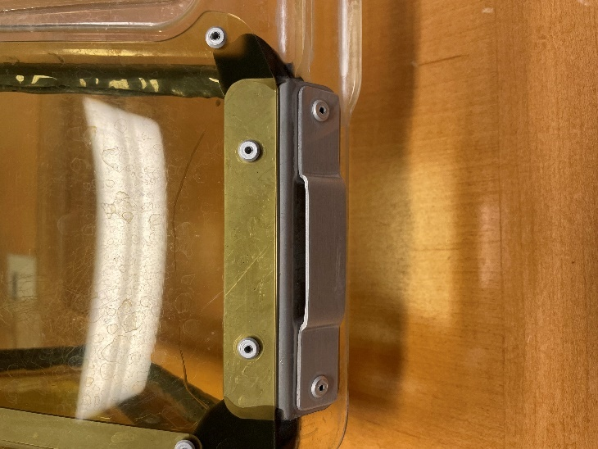

* + 1. At all ten other points of attachment, the 97447A020 rivets are sufficient
    2. The two rivets through the bottom lip on the left side of the lid need to be ground flush to the plastic on the inside of the lid

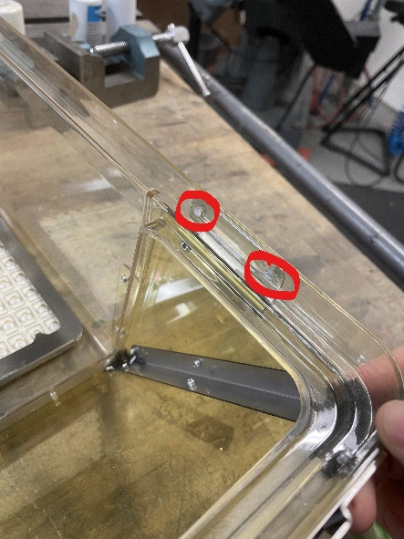 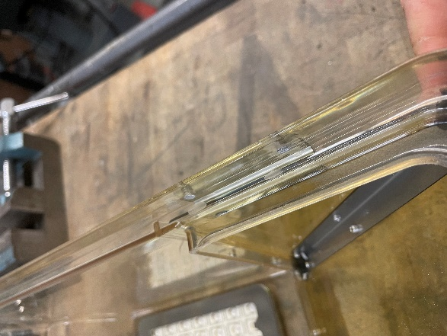

1. Assemble Water Bottle Holder Cover and Attach to Cage

Parts:

|  |  |
| --- | --- |
| Part | Quantity |
| rat water bottle transition | 1 |
| bottom taper section of right water bottle holder | 1 |

* 1. Epoxy bottom taper section of right water bottle holder to the bottom of the machined rat water bottle transition part

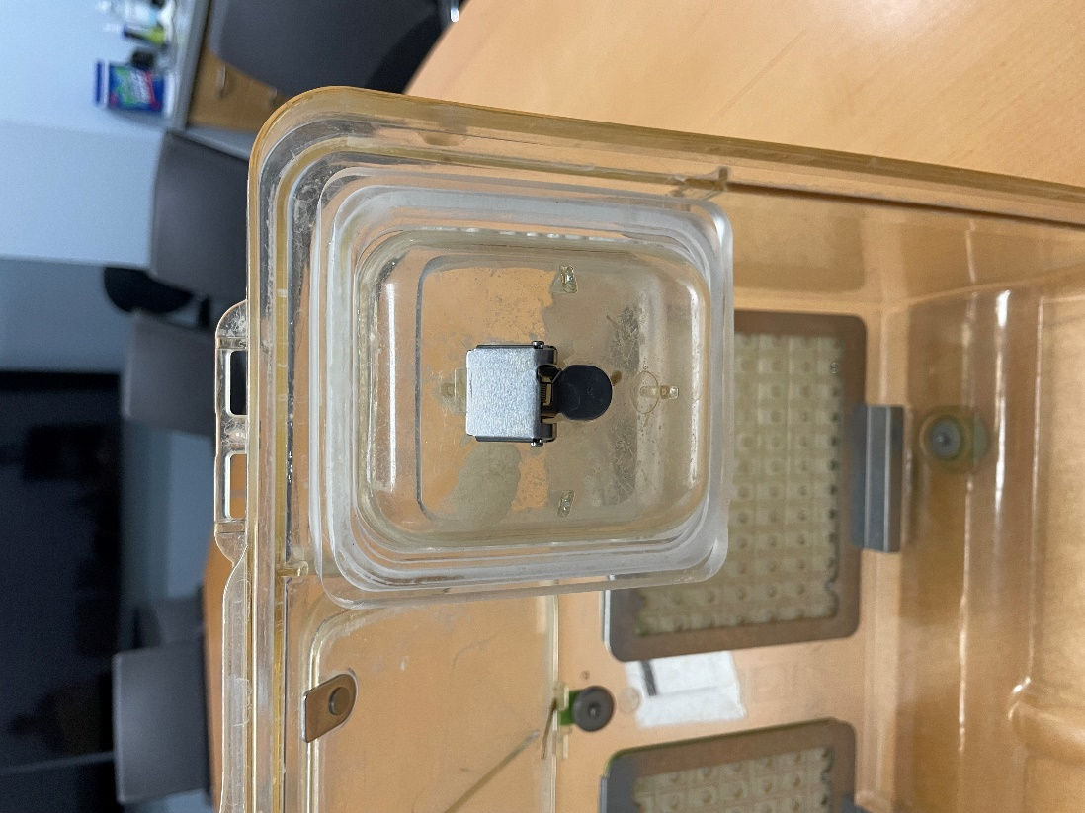

* 1. Epoxy this combined part onto the rest of the cage where the right water bottle holder was originally located

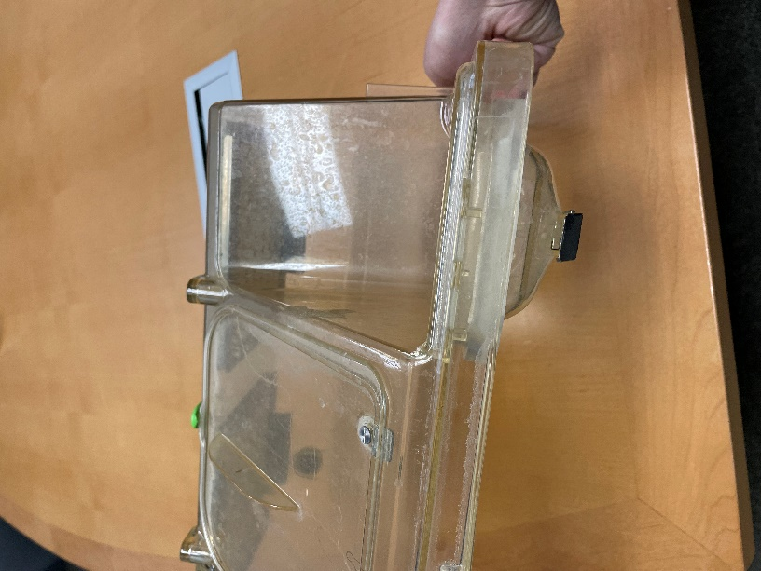

1. Epoxy
   1. Seal the corners of the covers with epoxy (7467A65)
      1. Circled corners need epoxy

Note: There is epoxy all the way around the cut opening in the left side of the lid in these photos – that is leftover from a different modification. Do not replicate this

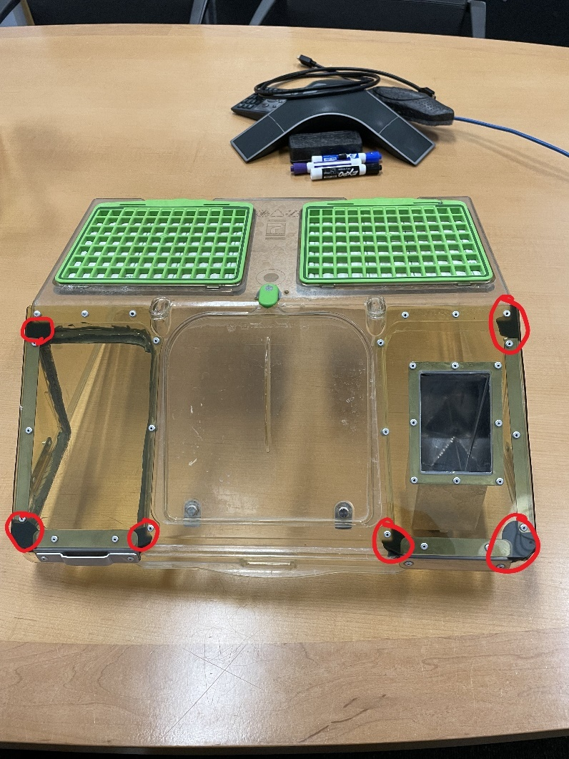

* + 1. Tape over the openings

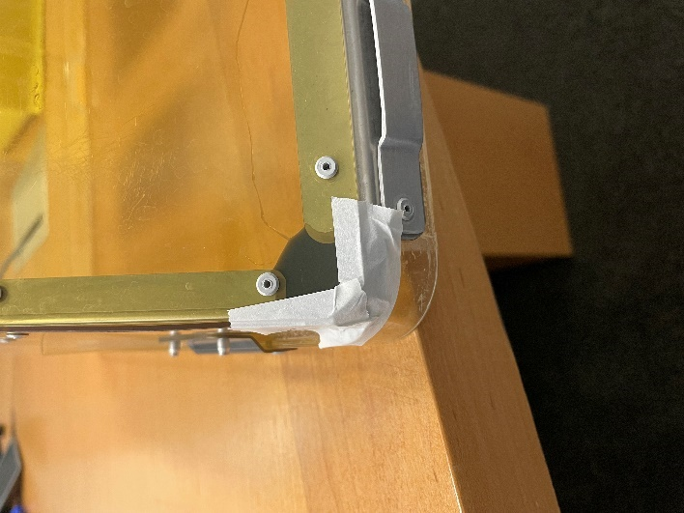 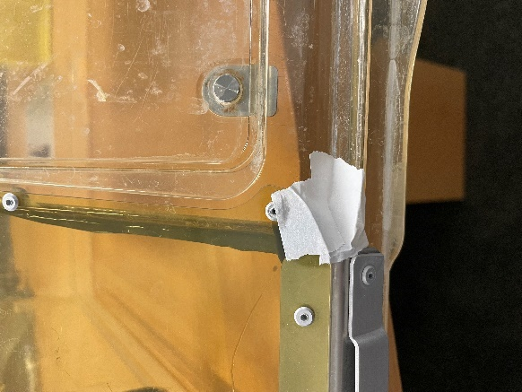

* + 1. Inject epoxy with applicator gun from the inside of the lid

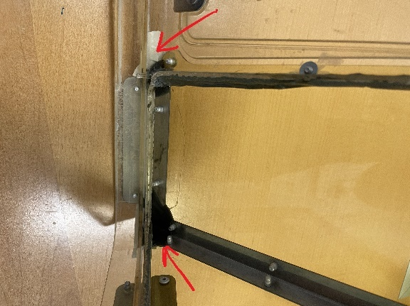

* + 1. Stand on end to prevent epoxy from running and let dry 24 hours before removing tape